“ Provision of Cooked Food for poorer households and Migrants” Deoghar Municipal Corporation,Deoghar, Jharkhand

- Innovation / What Initiative Were Taken :-Provision of Cooked Food for Poors and Migrants by SHGs formed under SM&ID Component of DAY-NULM
- Innovation/ Initiative Type*:- Food-Community Kitchen.
- Innovation/ Initiative Taken by*:-
Deoghar Municipal Corporation(Including Municipal Commissioner and City Mission Managers and Community Organisors of DAY-NULM)
- Convergence with any Department:- Yes.
Supply Department of Deoghar,Jharkhand.

- Details of Initiative*:- (max. 200 Words)
The World Health Organisation(WHO)has declared that the new corona virus outbreak is a public health emergency of international concern, officials announced on Thursday,30th January,2020.WHO proposed calling the disease”2019-nCoV acute respiratory disease”. The 2019 novel corona virus(COVID-nCoV)originating in Wuhan,China has now spread almost all over the world and alarming public health authorities across the world. At present more than 265000 peoplehave died and over 3800000 have been infected globally.
To prevent the spread of COVID-19, National lockdown has been imposed by Hon Prime Minister since 25thMarch 2020 to17thMay 2020 in three phases to save entire citizens. In such condition, there is essential to maintain the rules of Lockdown to break the chain of COVID-19,which has now widely dispersed and impacted many lives and livelihood in the country.
Obeying the nation guideline Jharkhand is also following the lockdown since starting,as Jharkhand State is also affected from this pandemic COVID-19 and number of cases also increasing with each passing day. The Jharkhand government is very serious over the rules of lockdown and even in third phase of lockdown no relaxation have been given to any part of the state as per the announcement of Hon. Chief Minister Shri Hemant Soren. This lockdown situation is worstely affecting the economic activities in the state. This is a very crucial time for daily wage earners, Footpath vendors, Vegetable vendors, Rickshaw-Auto Rickshaw drivers,migrants etc, as they have lost their earnings due to lockdown and at the point of starvation especially in the urban areas.
Hence, the role of ULB becomes more crucial to provide as well as maintain the provision of basic services to their citizen for sustainability during these lockdown periods and provide the food to poor’s and needies. Taking the social responsibility under the guidance of Municipal Commissioner DAY-NULM team of Deoghar Municipal Corporation started Operating two Dal-Bhat Kendra, one at Suvidha Hotel, Vidyapati Chowk and another at Krishi Vipanan Kendra,Chandpur through SHG women of Maa Bhawani Swayam Sahayata Samuh and Jaikara swayamsahayata Samuh with the help of supply department of District Administration,Deoghar on 10/04/2020 to serve cooked food among the 200 needy and marginalized people to each centre.
Some Related Photographs
Office Order to Operate Dal-Bhat Kendra (Sl.no.-7)
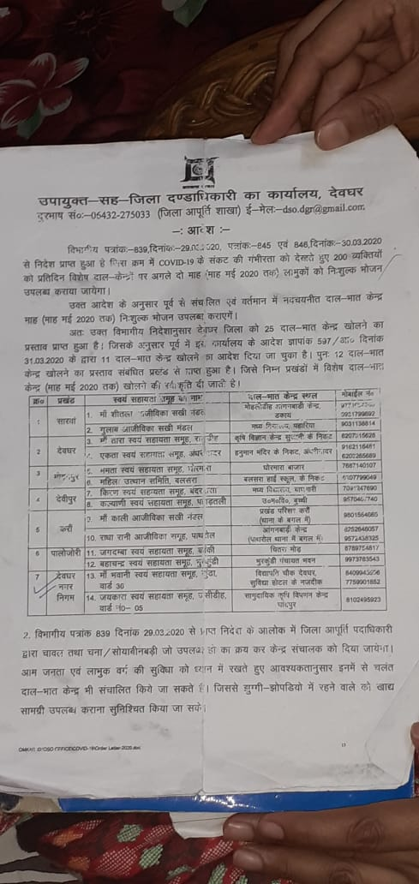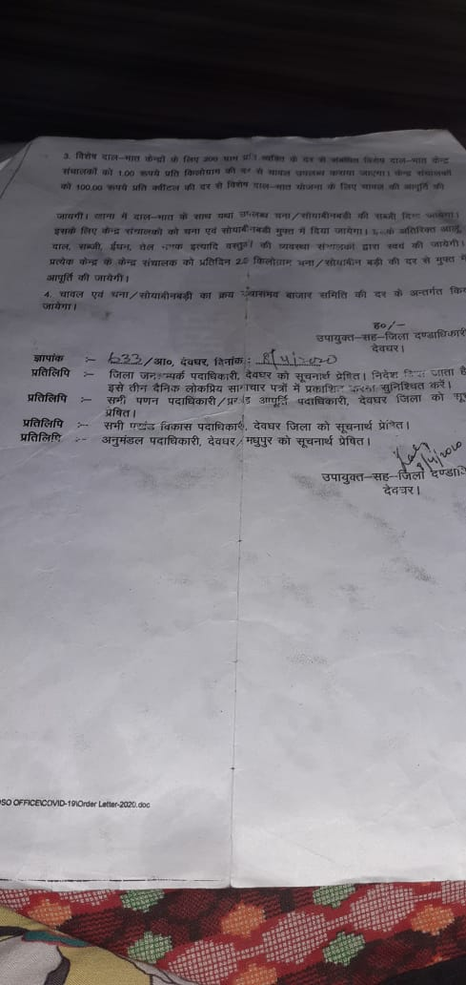
Press Clip of Inauguration of Vishesh Dal-Bhat Kendra
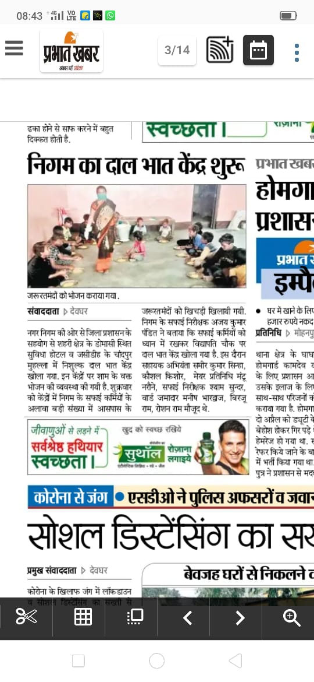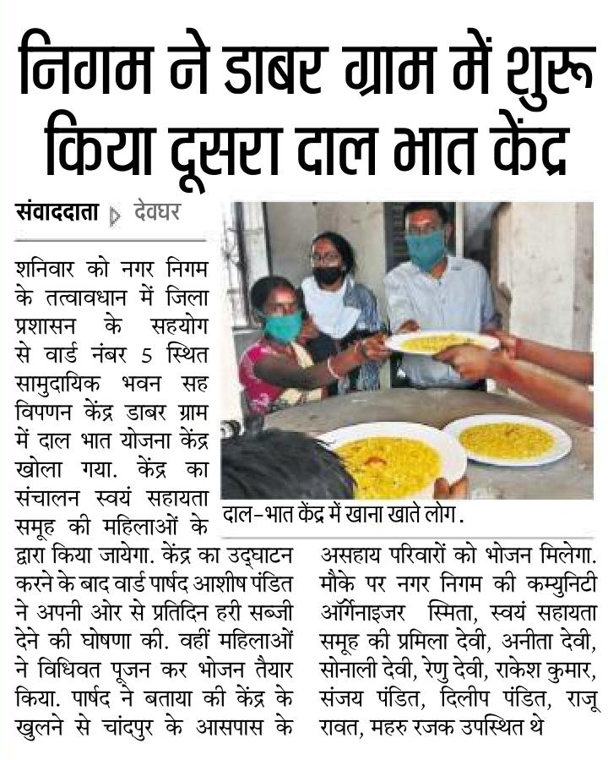

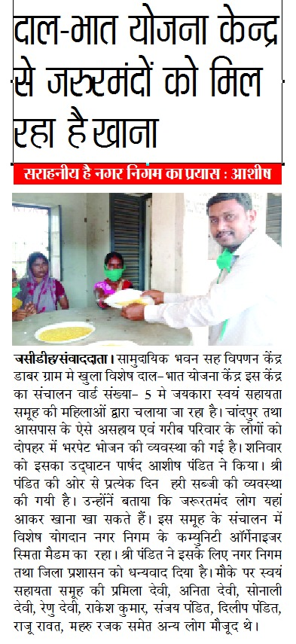
Operation of Dal-Bhat Kendra:
Since starting both Kendra are operating by SHGs members in very systematic manner following the guidelines of district administration for operation of these kendras as well as prevention from COVID-19. DIdis are serving healthy and hygienic food to approx 200-250 needy people on each centre,maintaining the proper social distancing and using gloves and mask during preparation and serving of food. Also conducting sanitation awareness drive among beneficiaries with the help of other Departments / Agencies.
Silent Features:
- Preparation of Healthy Food in a hygienic Manner.
- Serving Healthy Food with hospitality .
- Maintaining Social Distancing .
- Providing Hand wash facility.
- Conduction of Sanitation Awareness drive for beneficiaries.
- Providing take home food facility for family.

Some Glimpses of Activities in Photograph

Preparation of Healthy Food in a hygienic Manner
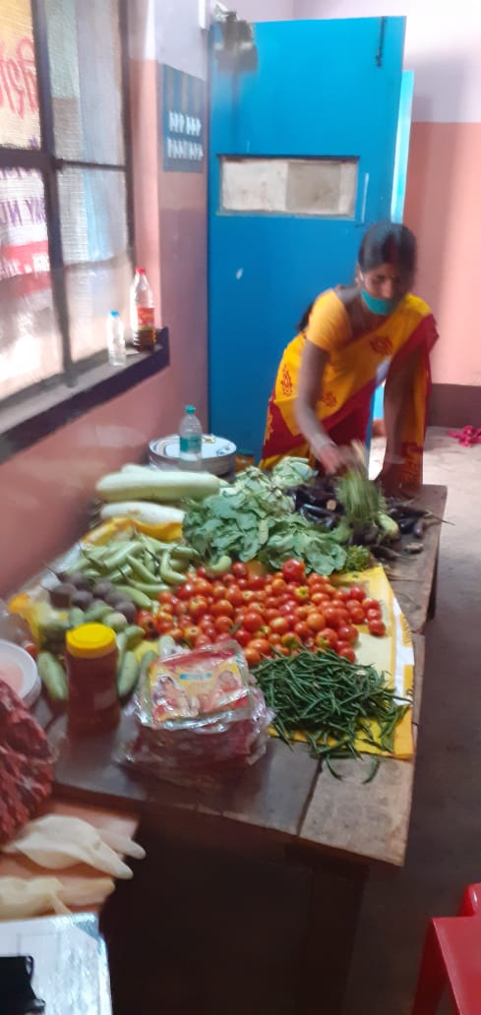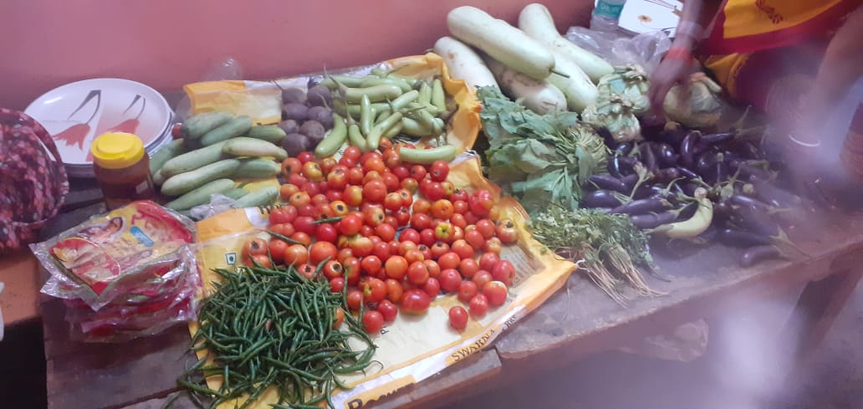
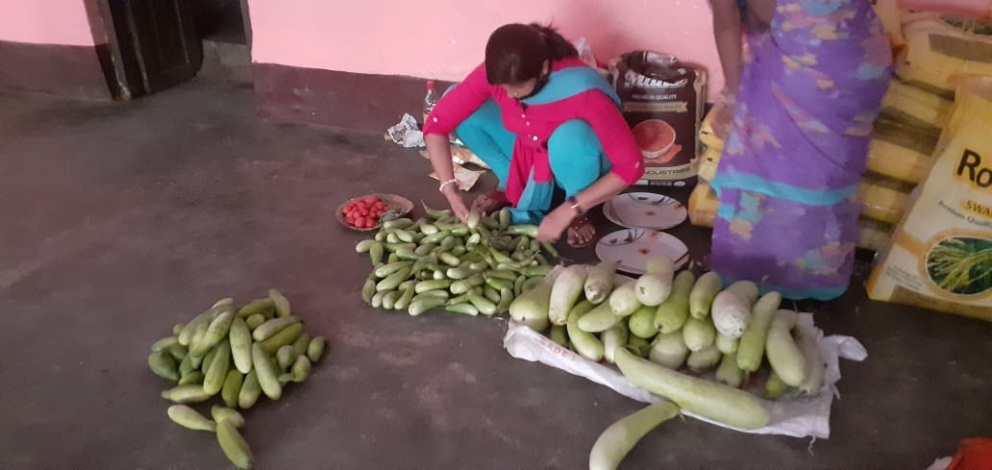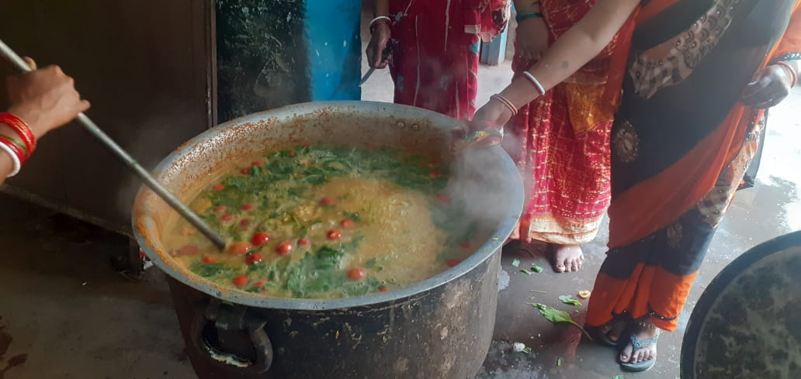
Serving Healthy Food with hospitality
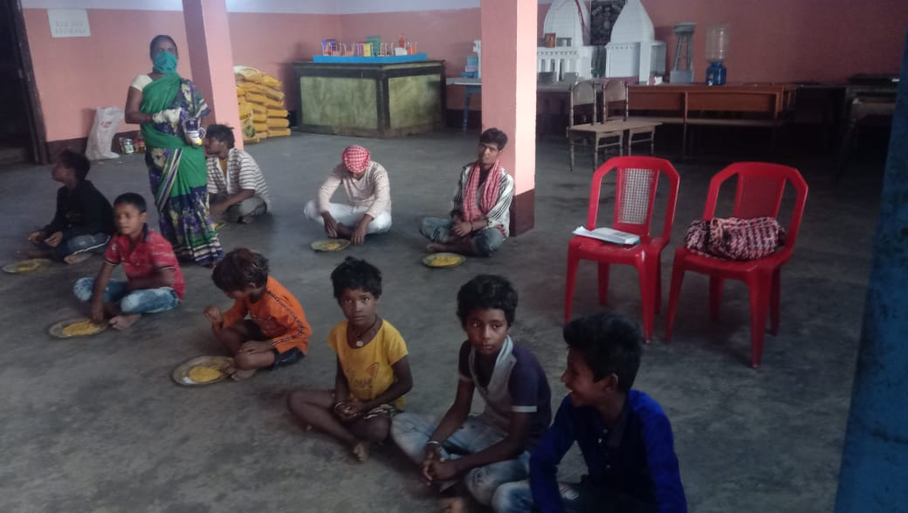

Maintaining Social Distancing
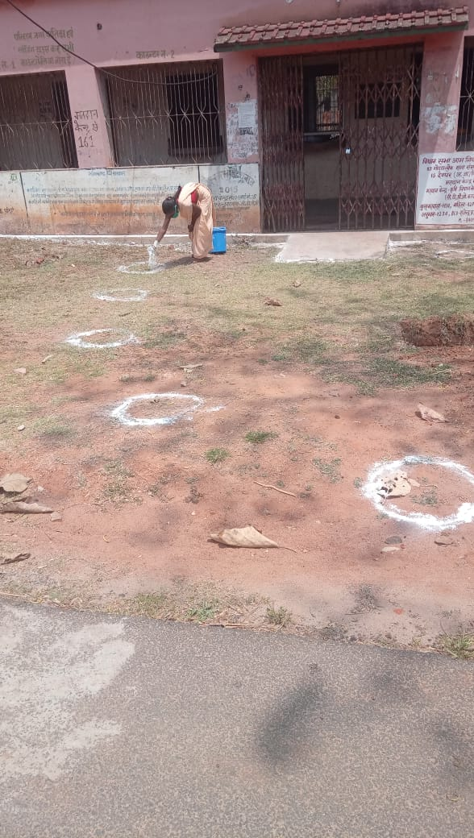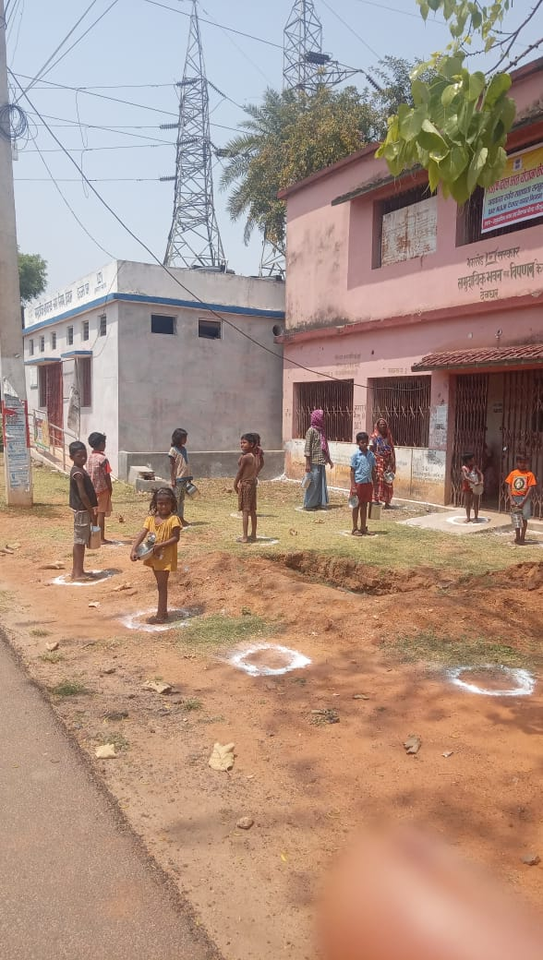
Hand wash Training with Child Line and Hand washing
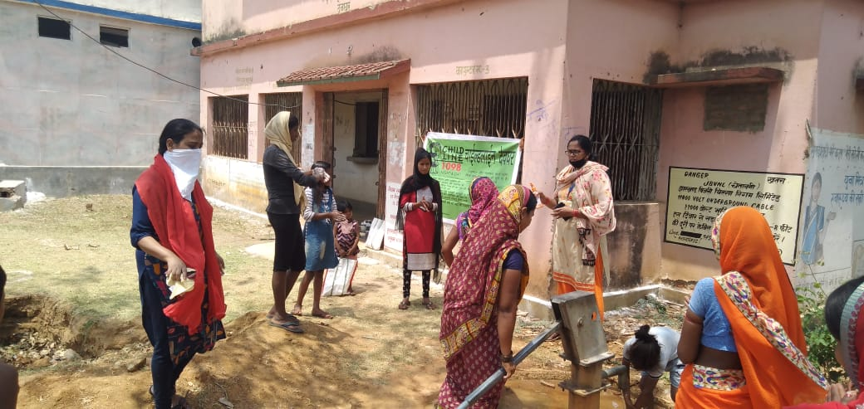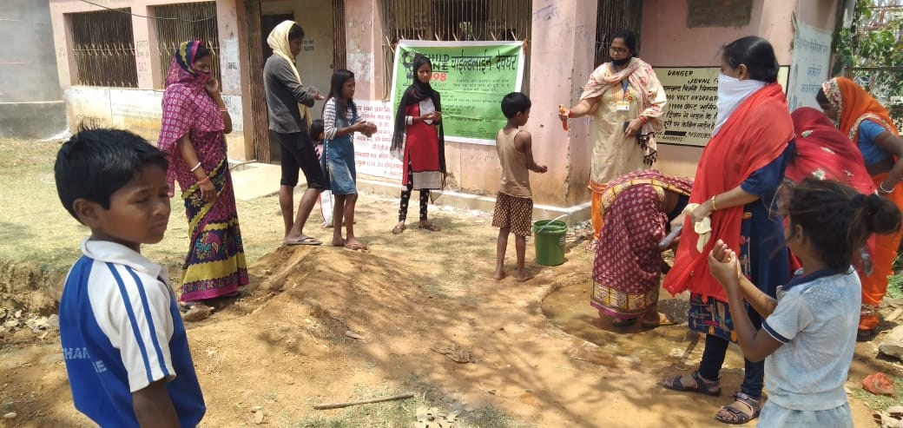
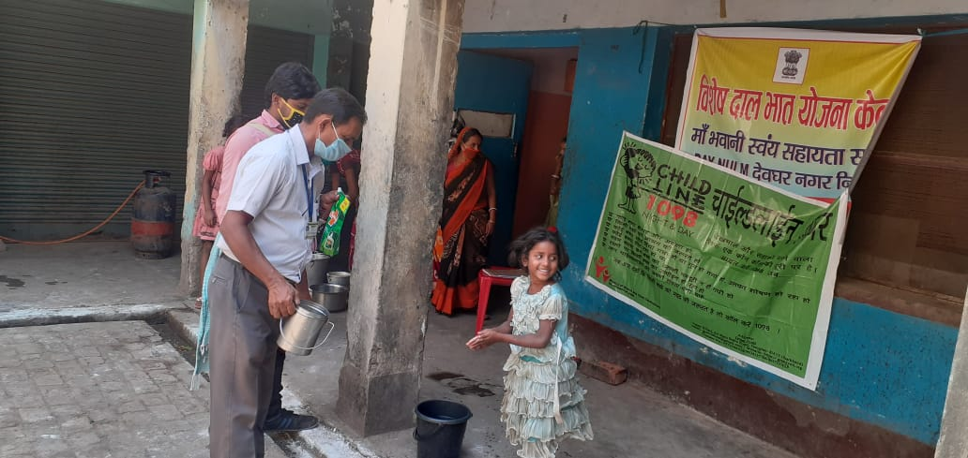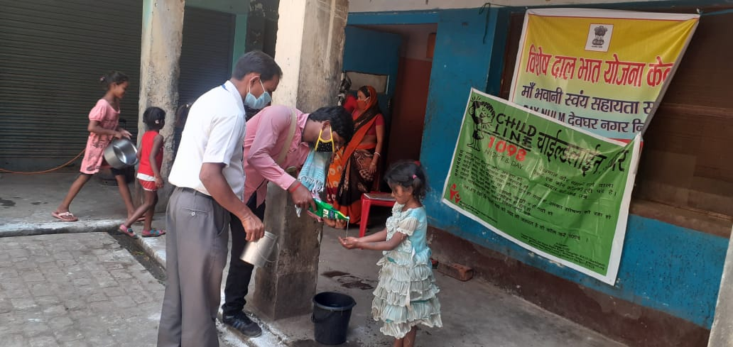

Take Home Food Facility
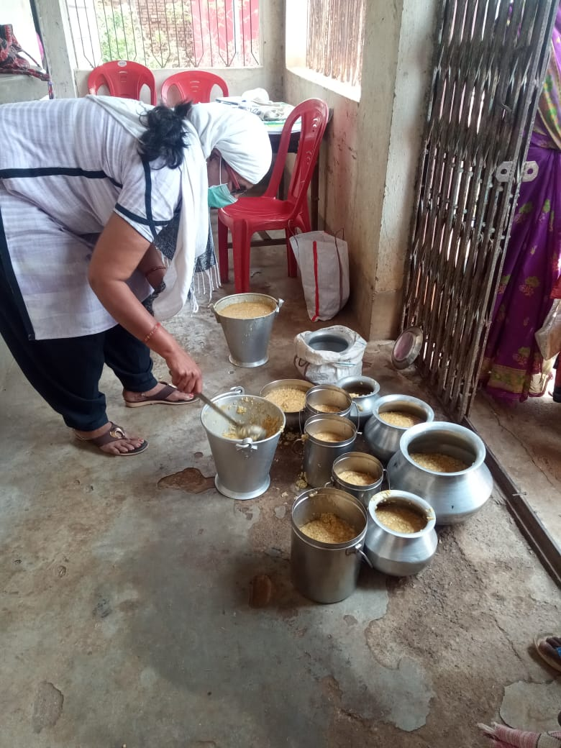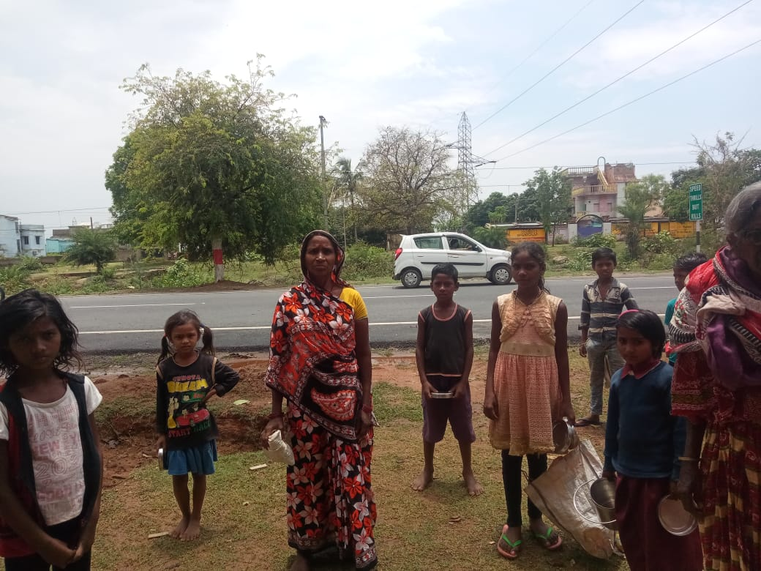

- Place*:- Deoghar Municipal Corporation,Deoghar, Jharkhand.

- Present Status of Initiative:- Ongoing

- Start Date:- 10-04-2020

- End Date:- Ongoing

- Mobilisation of Resources if any (CSR/CSO) :-No

- Type of Benefits
- Needy People getting free healthy , hygienic and testy food.
- Spreading awareness on COVID-19,social distancing and sanitation practices.

- SOCIAL MEDIA PLATFORM USED

Facebook Page-https://www.facebook.com/deogharnagar.nigam.507
Twitter Handle-
Youtube Channel-
Website – www.dfcajharkhand.in
Other -
- TOTAL MANPOWER RESOURCE INVOLVED
DAY-NULM Staff – CMM-2,CO-02,

Govt.- 00
Non-Government – 00
Volunteer - 13(SHG Mambers)
Any Other-0

14. COVERAGE
No of Households Covered - 1185
No of Citizens Benefited – 6160
15.Total Expenditure Involved (Rs. In Lakhs):-
16.Expenditure Borne by:- District Administration,Deoghar.
17. Helpline Numbers:-1967&1800-212-5512.

18.Purpose and Output of the Initiative (max. 200 Words):-
The purpose of this initiative is to serve healthy and hygienic food to needy peoples. At present approx 400-450 needy Peoples are getting hassle free healthy and hygienic food at these two centres. This is a great initiative taken by Deoghar Municipal Corporation and District Administration,Deoghar to save the poor’s and migrants from starvation. As people are getting cooked food nearby their houses, they are able to follow the rules of lockdown because they haven’t any need to go out from home in search of foods. Through sanitation training and awareness drives message is being spreading in the society on social distancing, Proper hand washing practices and sanitation. These are the strong tools to fight against COVID-19 and to achieve the goal of lockdown.
19.Any Other Information (max. 200 Words):-
Apart from serving food and providing training and awareness to beneficiaries at these centres, taking the moral responsibility to save the people from COVID-19 and starvation in municipal area we are serving cooked food to marginalised people who are not able to come on these centres in camp mode and using these platform to spared the messages on prevention against CIVID-19 and to provide training on Hand washing, sanitation, social distancing etc. Two such camp have been conducted till now:
1.At kusht ashram,Deoghar, among the people suffering from leprosy: In this ashram lives the people who are suffering leprosy, most of them are baggers ,provided cooked food to 245 people and aware them on prevention against COVID-19, importance of Hand washing ,use of Mask ,social distancing and sanitation etc.
Photograph and Media Clip
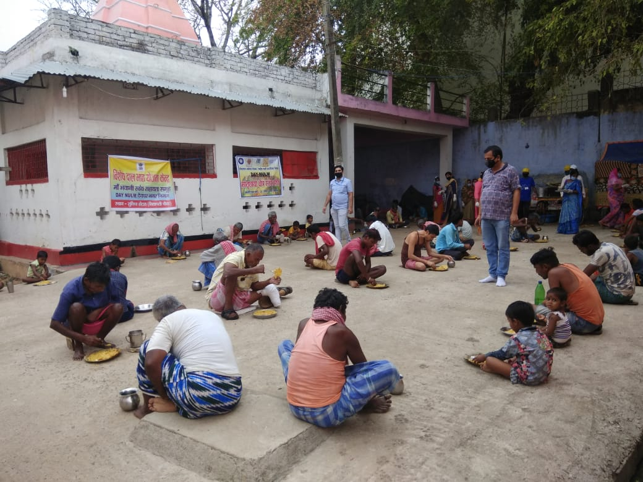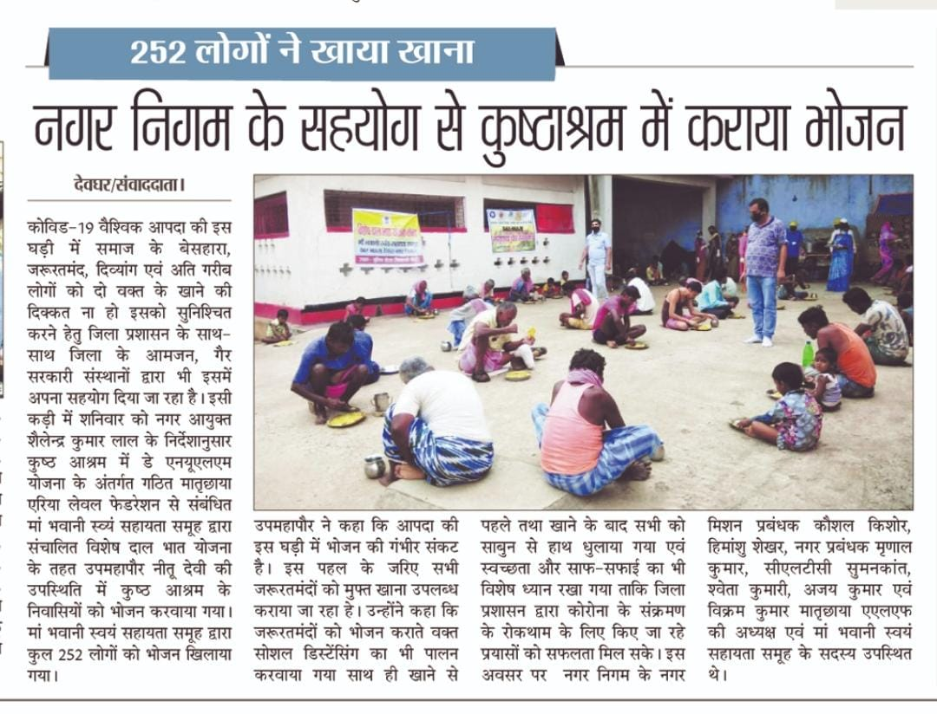

2.For Divyang children and Old age people at Saras Kunj,Deoghar: Another such camp was organised at Saras Kunj,Deoghar, a shelter home for Divyang/orphan children and Old age persons. Delicious food (Khir,Puri,Sabji, Mithai, Salad) served and aware them on on prevention against COVID-19, importance of Hand washing ,use of Mask ,social distancing and sanitation etc and given them Mask and Sanitizer.
Media clip and Photograph
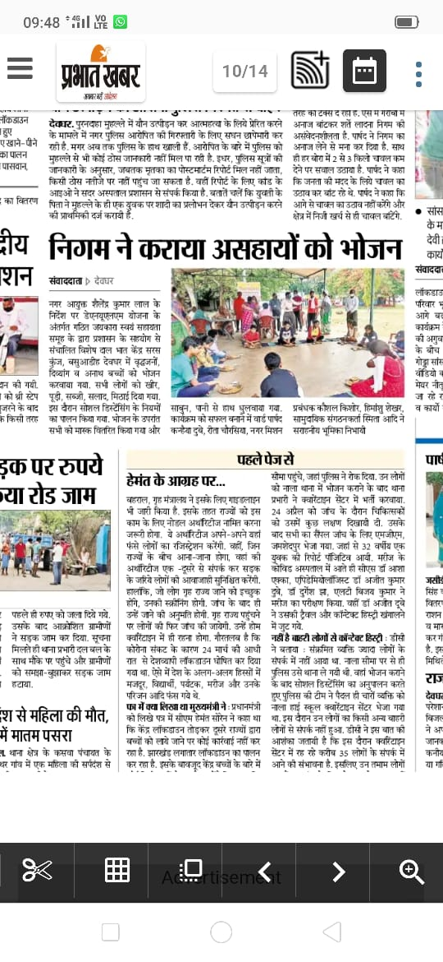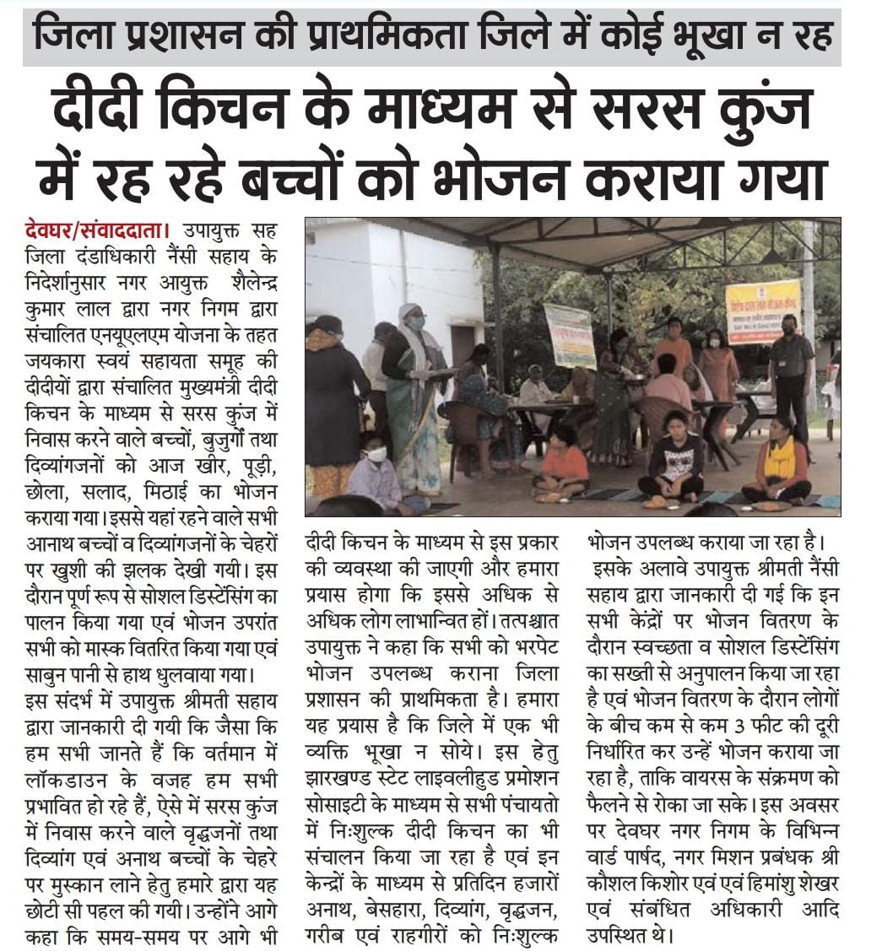

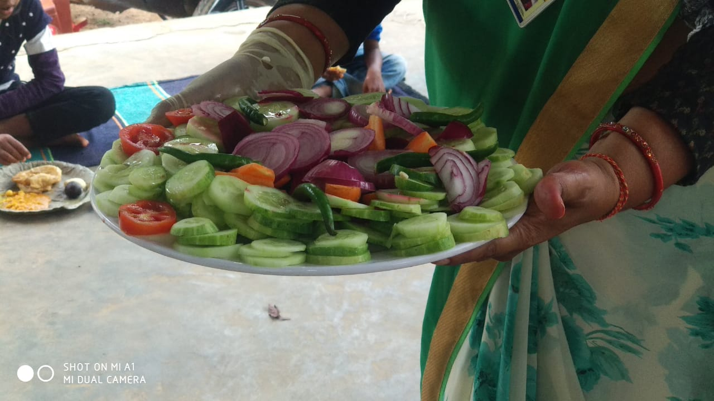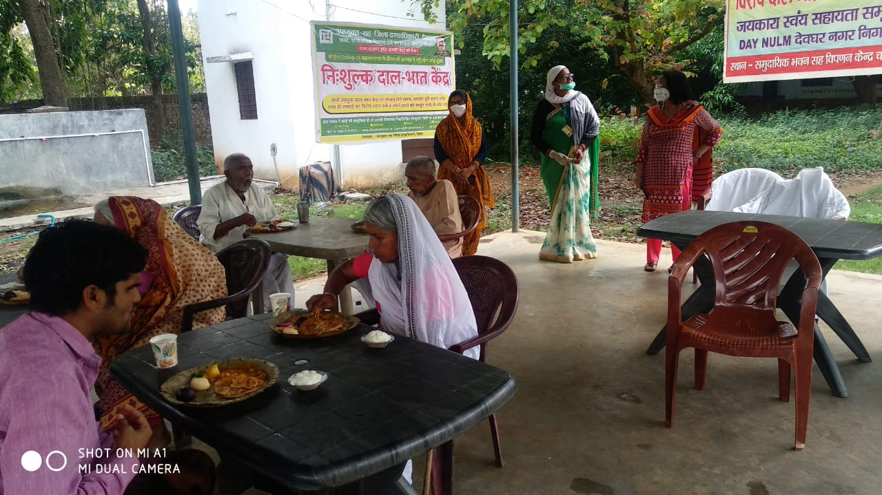
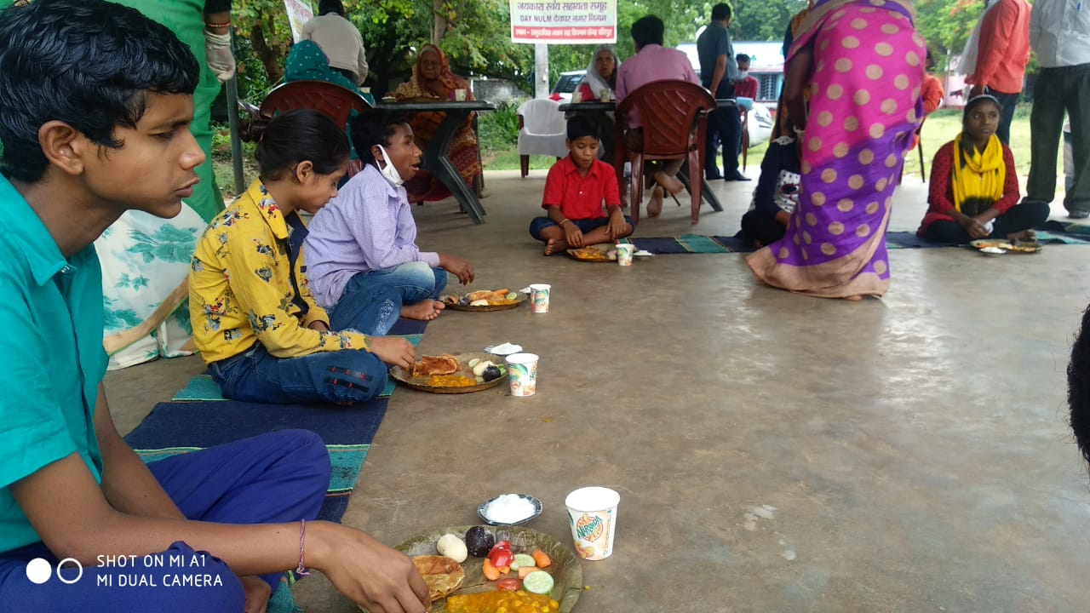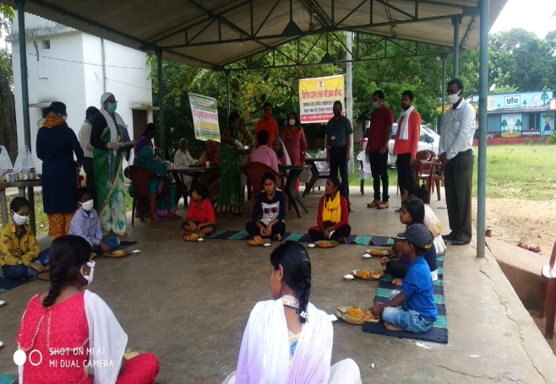

Way forward:
- Another camp is proposed in Rohani,Deoghar and so on another places.
- Approval of one other Dal-Bhat Kendra is under process for 200 people/day.
- We have plan to run such Kendra in all three shelters homes and all 36 wards to cover all poor people of municipal area.
- Some SHGs are preparing mask for free distribution among needy people.
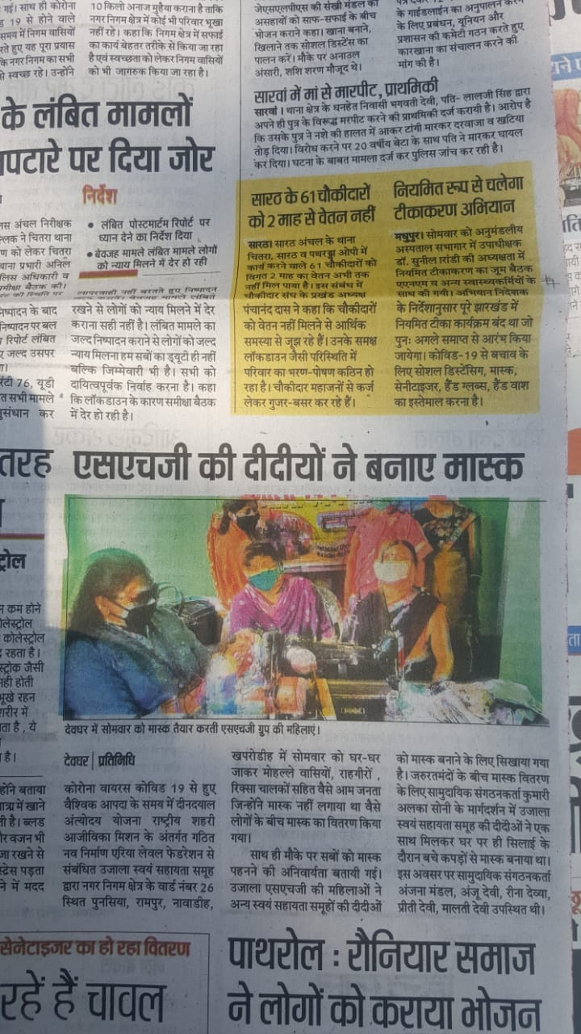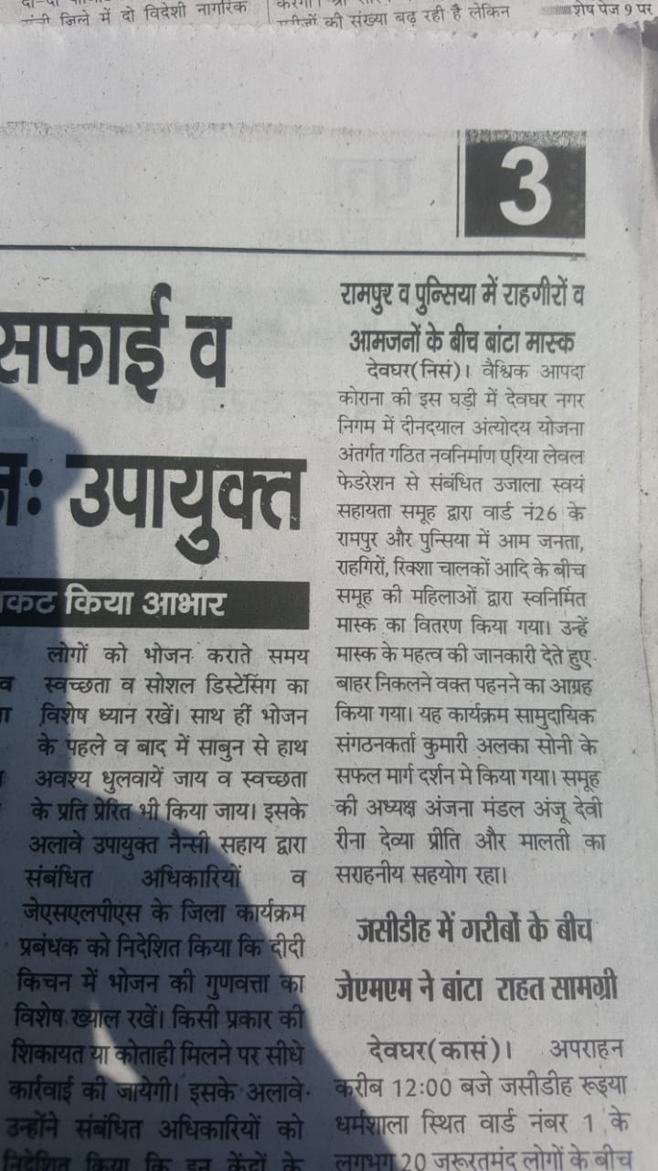

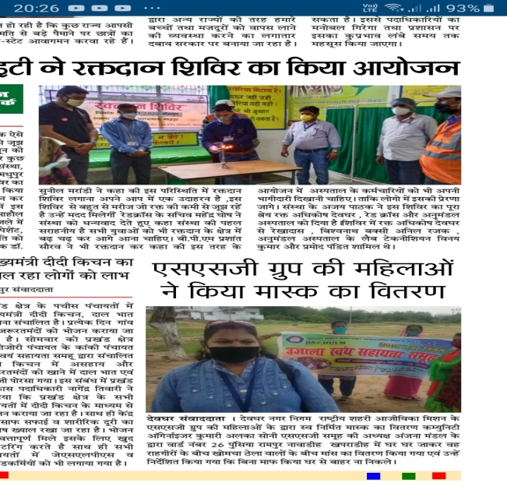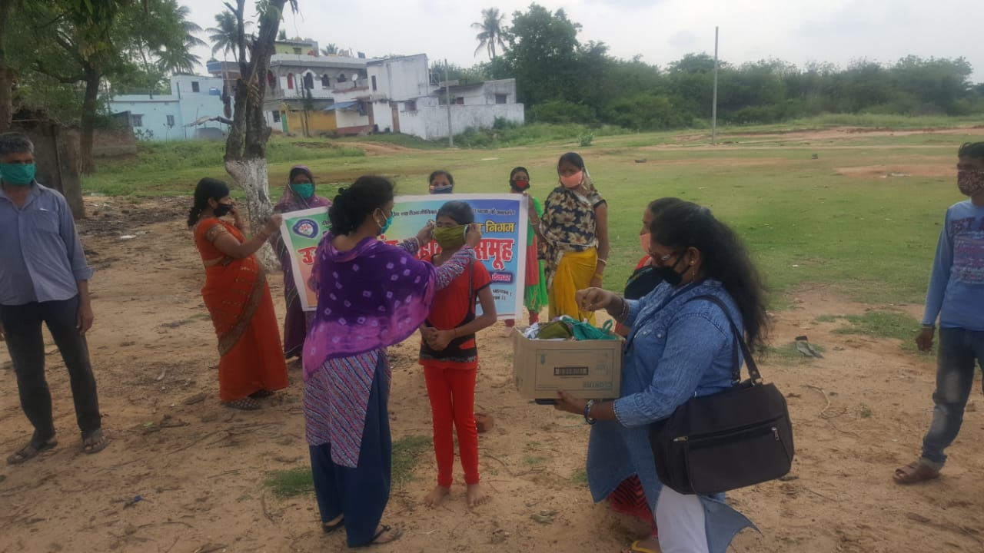
- Preparation and Distribution of Mask by Skill Trained Candidates and Training Centre:
Skill providers of DAY-NULM and Skill trained candidates are also involve in various activities such as preparation of Mask, distribution of mask and Soap and conduction of awareness drive .
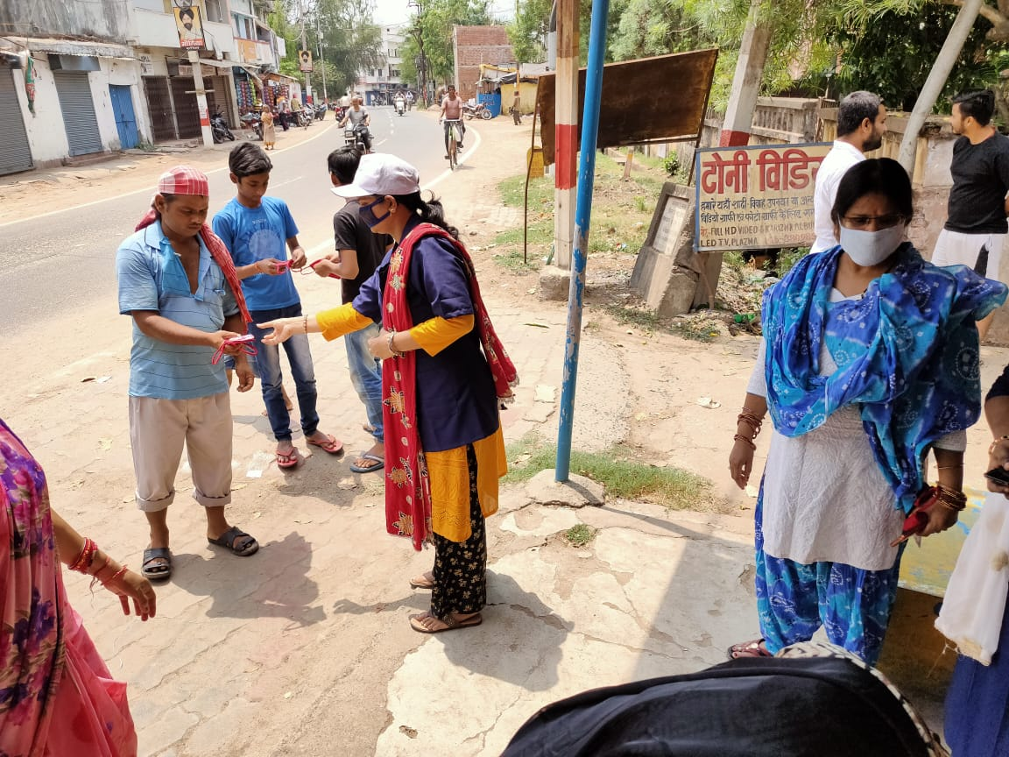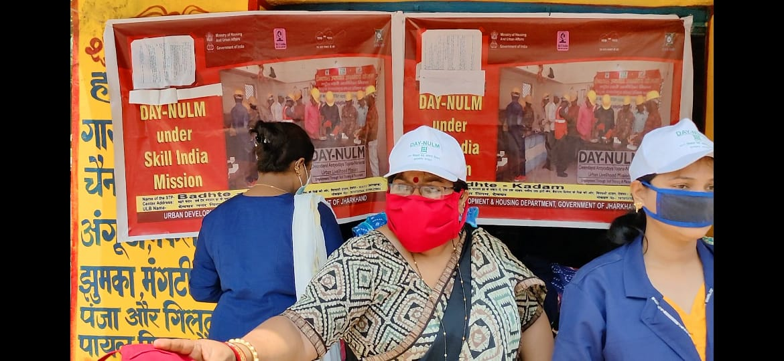

20.How (max. 200 Words):-
- Awareness through Social,electronic and print Media.
- Through conduction of awareness drives.
- Training and Compaign.
- Regular close monitoring.
- Coordination with other departments and agencies.

- Monitoring Methods/Tools (If Any) (max. 200 Words) –
The monitoring method involves monitoring by Municipal Commissioner, City Mission Managers and Community Organizer of DAY-NULM. Providing hand holding support to SHGs operating Dal-Bhat Kendra and other activities .

*************

